**

***LAB # 04***

*To understand arrays and its memory allocation.*

November 4, 2024

**

***LAB TASKS***

***TASK # 01***

*Write a program that takes two arrays of size 4 and swap the elements of those arrays.*

*INPUT*

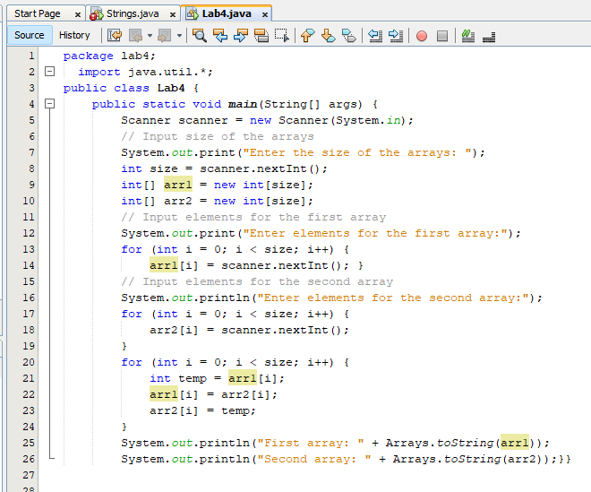

*OUTPUT*

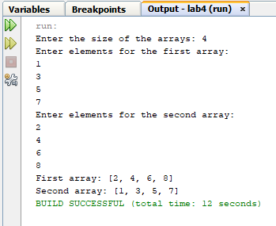

***TASK # 02***

*Add a method in the class that takes array and merge it with the existing one.*

*INPUT*

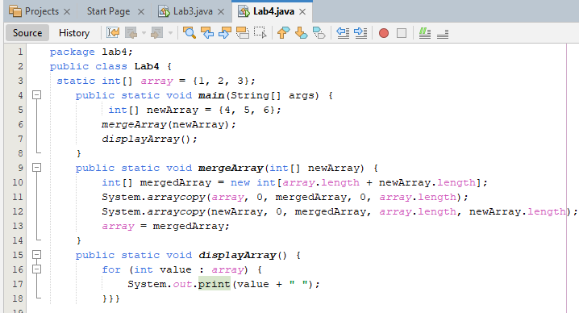

*OUTPUT*

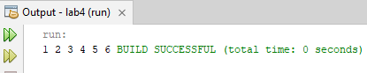

***TASK # 03***

*In a JAVA program, take an array of type string and then check whether the strings are palindrome or not.*

*INPUT*

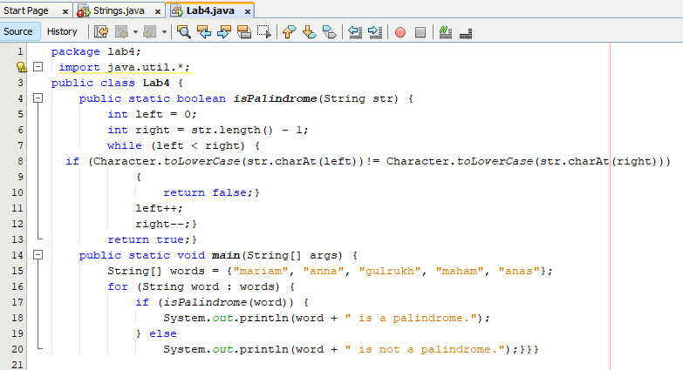

*OUTPUT*

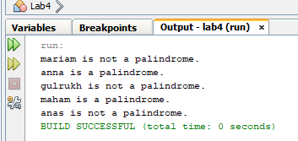

***TASK # 04***

*Given an array of integers, count how many numbers are even and how many are odd.*

*INPUT*

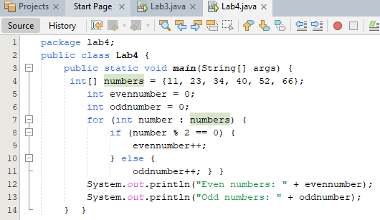

*OUTPUT*

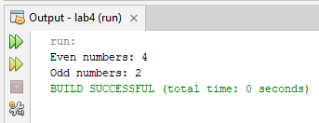

***TASK # 05***

*Given two integer arrays, merge them and remove any duplicate values from the resulting array*

*INPUT*

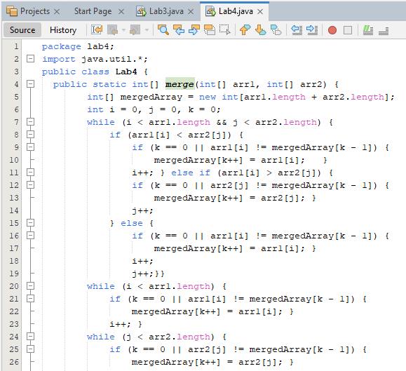

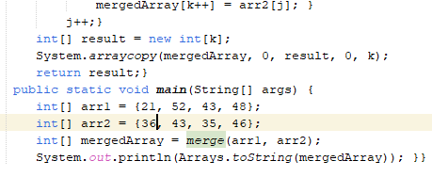

*OUTPUT*

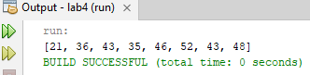

***HOME TASKS***

***TASK # 01***

*Write a program that takes an array of Real numbers having size 7 and calculate the sum and mean of all the elements. Also depict the memory management of this task.*

*INPUT*

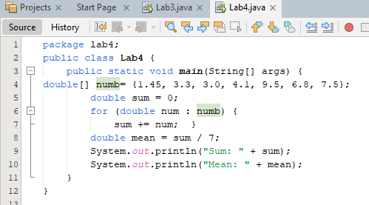

*OUTPUT*

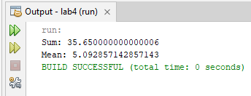

***TASK # 02***

*Add a method in the same class that splits the existing array into two. The method should search a key in array and if found splits the array from that index of the key*

*INPUT*

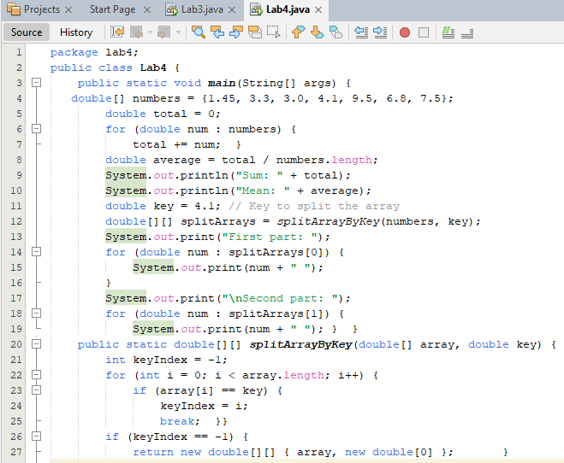

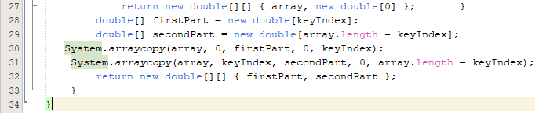

*OUTPUT*

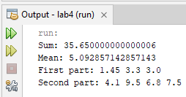

***TASK # 03***

*Given an array of distinct integers and a target integer, return all unique combinations of numbers that add up to the target. Each number can be used only once in the combination.*

*INPUT*

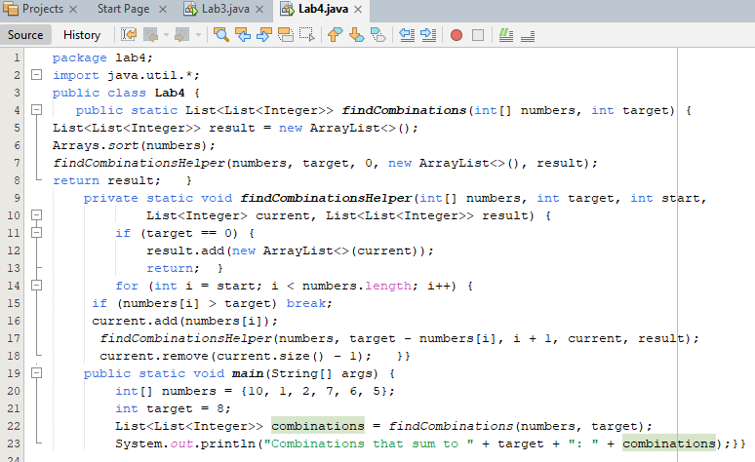

*OUTPUT*

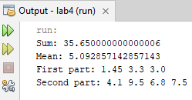

***TASK # 04***

*You are given an array containing n distinct numbers taken from 0, 1, 2, ..., n. Write a program to find the one number that is missing from the array*

*INPUT*

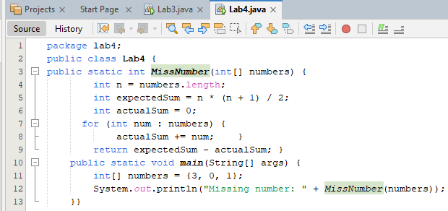

*OUTPUT*

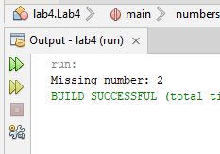

***TASK # 05***

*You are given an array of integers. Write a program to sort the array such that it follows a zigzag pattern: the first element is less than the second, the second is greater than the third, and so on*

*INPUT*

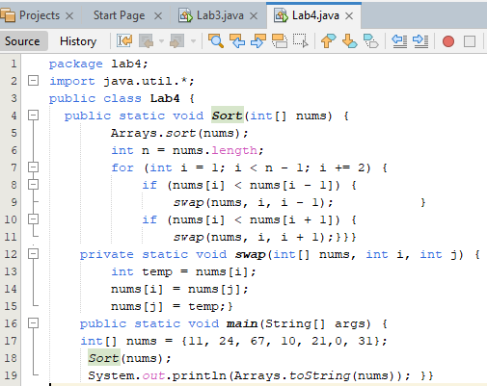

*OUTPUT*

